**1.How to connect Mio with iphone to get heartrate data**

For connecting and transporting data from health kit, we need to connect the MIO device with iPhone through Bluetooth. Then open “Health” app, go to “Health data” and click “vitals”. After this process, we are able to access the data.

**2.Through Unity->xcode->iphone to install our game app**

(1)once you have built unity project successfully, open xcode project in xcode.

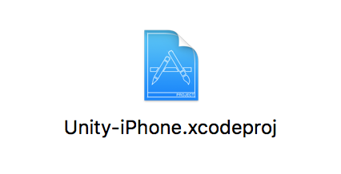

(2)change settings in xcode

1)in “*code signing identity*”: change all of them to “ios developer” as following:

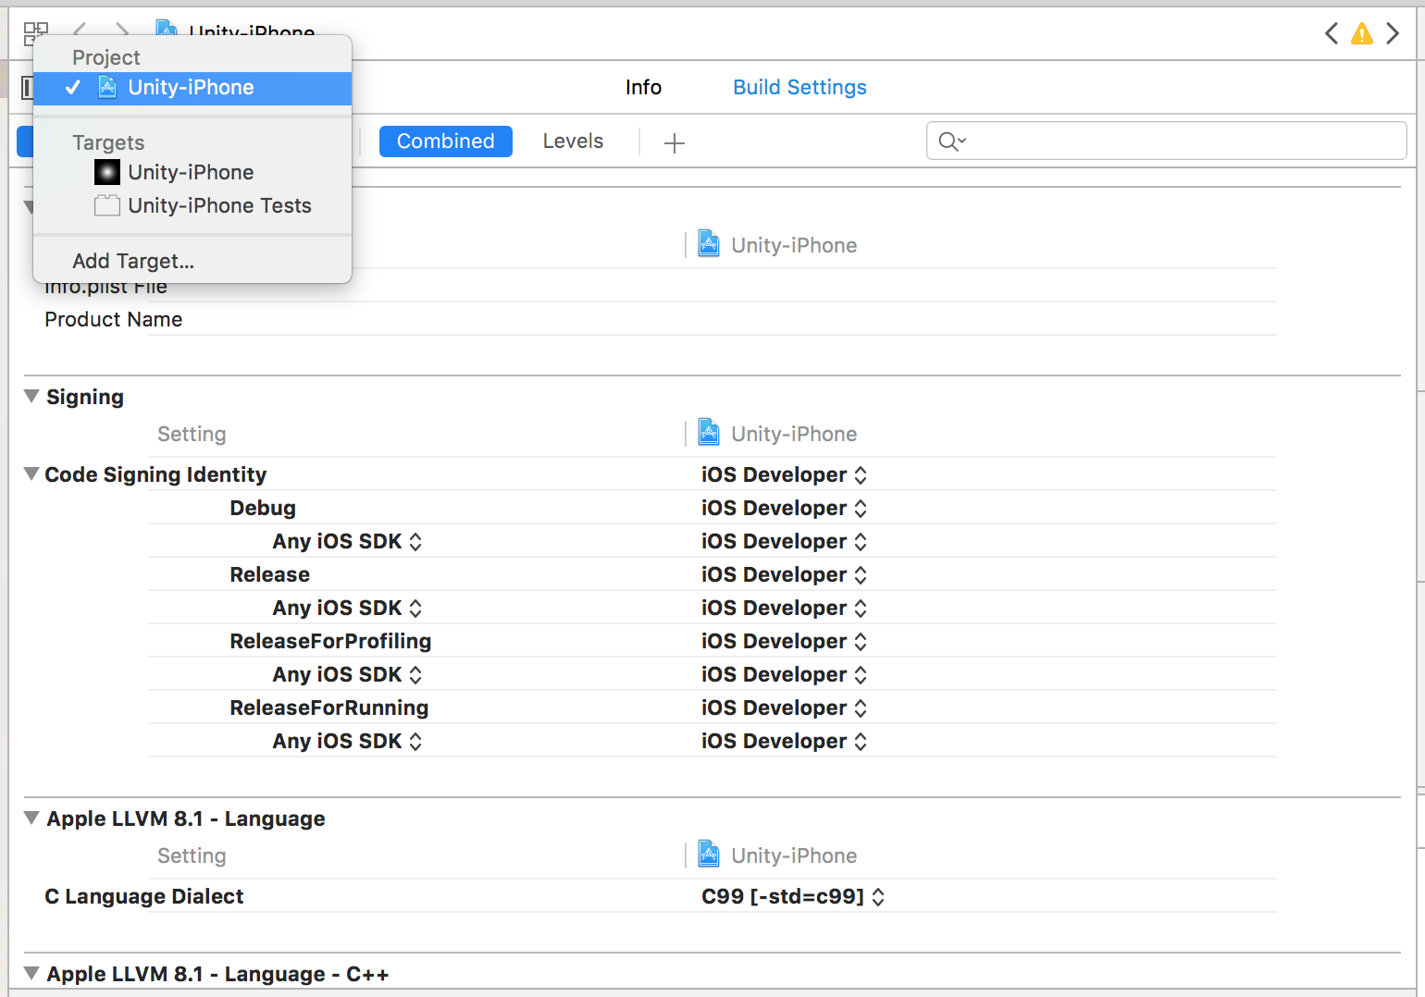

2)

in *general*:

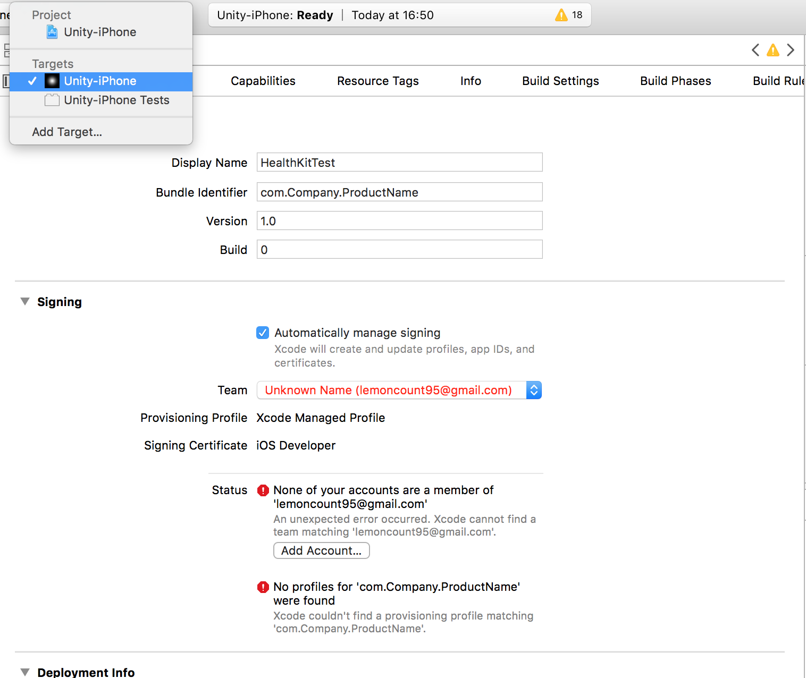

* First off, you need to add an apple account in xcode:

open “xcode->preferences”:

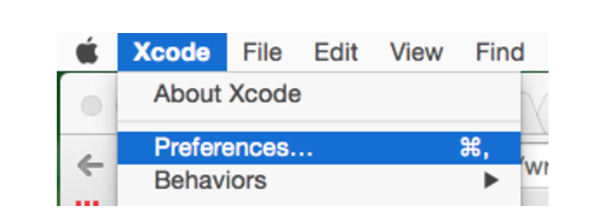

add your apple account which will be displayed as the following:

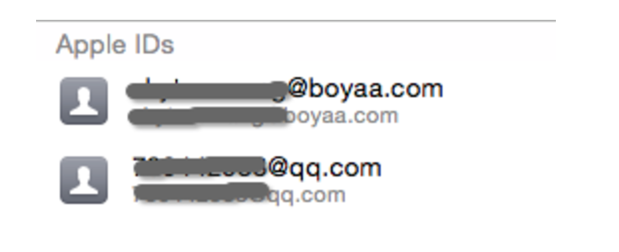

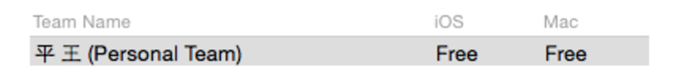

* second, change “Bundle Identifier:com.Company.ProductName” to a name as you want:

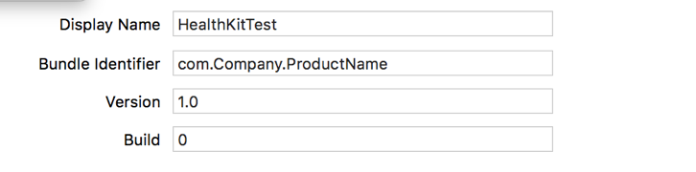

note: The name of your product should not be identical to other developers’, or xcode will give you error.

* Third, change team as following:

note:just use the apple account you added to xcode in the first step

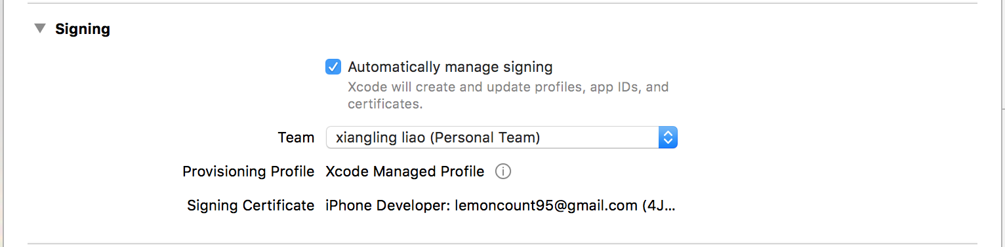

3)in “*capabilities*”:turn on “healthkit”

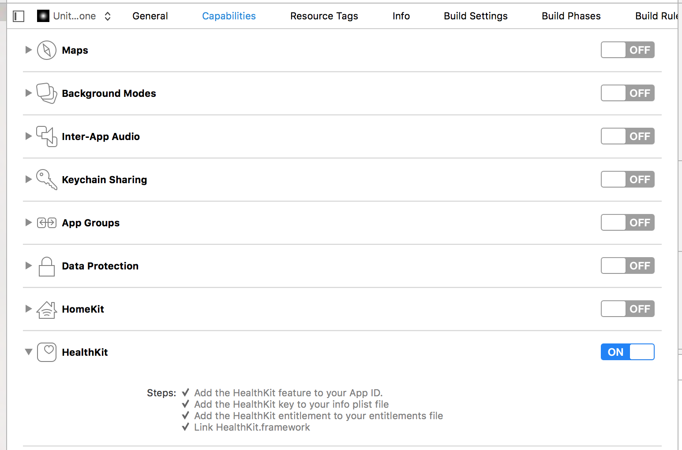

4)

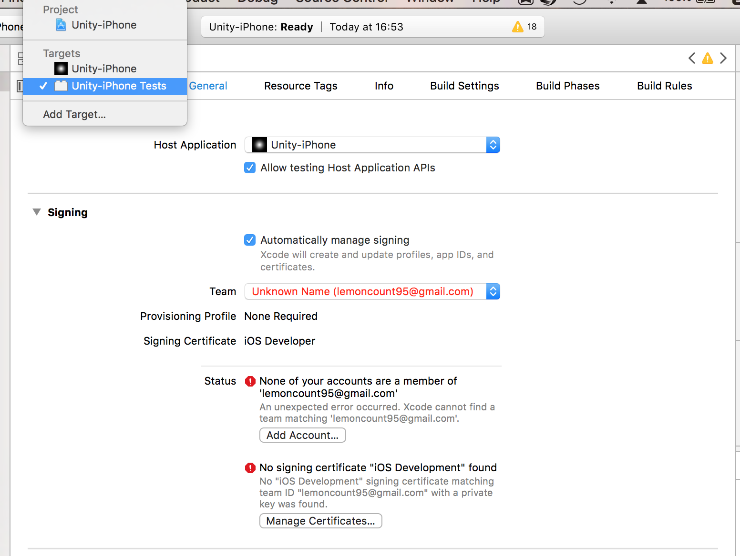

change team as following:

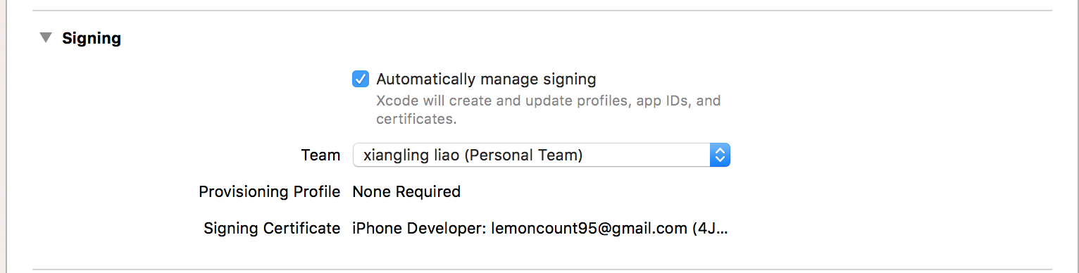

Finally, you can run xcode, and it will install the app on your iphone automatically.